**Admin guide Plant Patrol**



Admin guide Plant Patrol

Luuk Vlug

500807974

[luuk.vlug@hva.nl](mailto:luuk.vlug@hva.nl)

**Index**

**Introduction** **3**

**Necessary programs** **3**

**Github** **3**

**Connection** **3**

**Physical connection of the device** **3**

**Reading guide** **3**

**Setting up the .ino file** **4**

**Setting up the Wemos d1 mini** **5**

**Setting up the Arduino code** **6**

**XAMPP Setup** **8**

**Editing values for specific uses (optional)** **10**

# Introduction

In order for Plant Patrol to work, some adjustments have to be made to the code. This guide will explain what adjustments have to be made, and how this is done. With the help of useful screenshots, it will be easier to follow.

# Necessary programs

To be able to use this application, you will need a few applications, as certain data needs to be adjusted to your situation. The applications used for this are:

* Arduino (Link: <https://www.arduino.cc/en/main/software>)
* XAMPP (Link: <https://www.apachefriends.org/download.html>)
* (optional) Any text editor, I personally use Sublime (Link: <https://www.sublimetext.com/3>)

# Github

To make this admin guide even easier to follow, I uploaded all files necessary to Github, at <https://github.com/luukvlug1905/Plant-Patrol>. I recommend waiting before downloading all the files, and downloading the files you need for every step. For every step (where needed) there will be shown what files to download and where to put them.

# Connection

Plant Patrol is able to connect in 2 ways. Using a wifi network, or hotspot. It’s up to you which one you choose, but I will explain both. A few things to note however is that with a hotspot you can easily remove or change the password, but it will take longer to connect to the device and is less stable.

# Physical connection of the device

If for some reason some of the cables are not connected anymore, be sure to check the wiring diagram to see how everything is connected. Also check if the cables are connected properly if any form of malfunction is experienced.

# Reading guide

Step 1, 2 and 3 are about setting up the sensor and the arduino side of things.

Step 4 is about setting up XAMPP and the website.

Step 5 is an optional step to personalize the project to your needs.

# Setting up the .ino file

The first thing we’re going to do is set up the Arduino side. To start, download the Plant-Patrol.ino file from <https://github.com/luukvlug1905/Plant-Patrol>. If you haven’t done so already, download Arduino at: <https://www.arduino.cc/en/main/software>. Once Arduino has been installed, open the .ino file. When opening a new, downloaded .ino file in Arduino, you will see this popup:

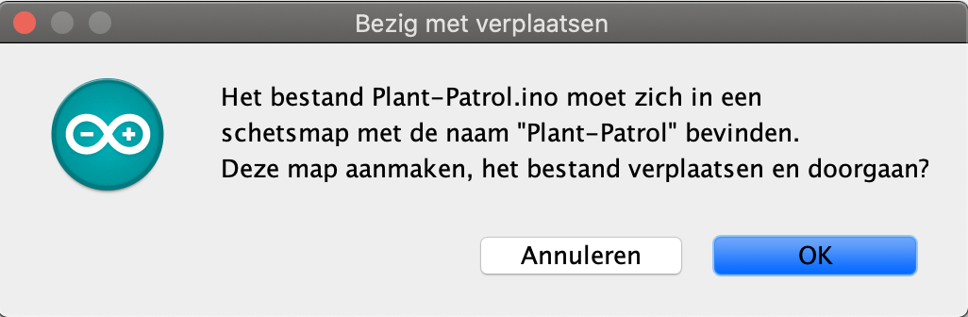

Here Arduino is asking to create a folder where the sketch (Plant-Patrol.ino) can be stored in. Click ‘OK’. You will be greeted with a page like this:

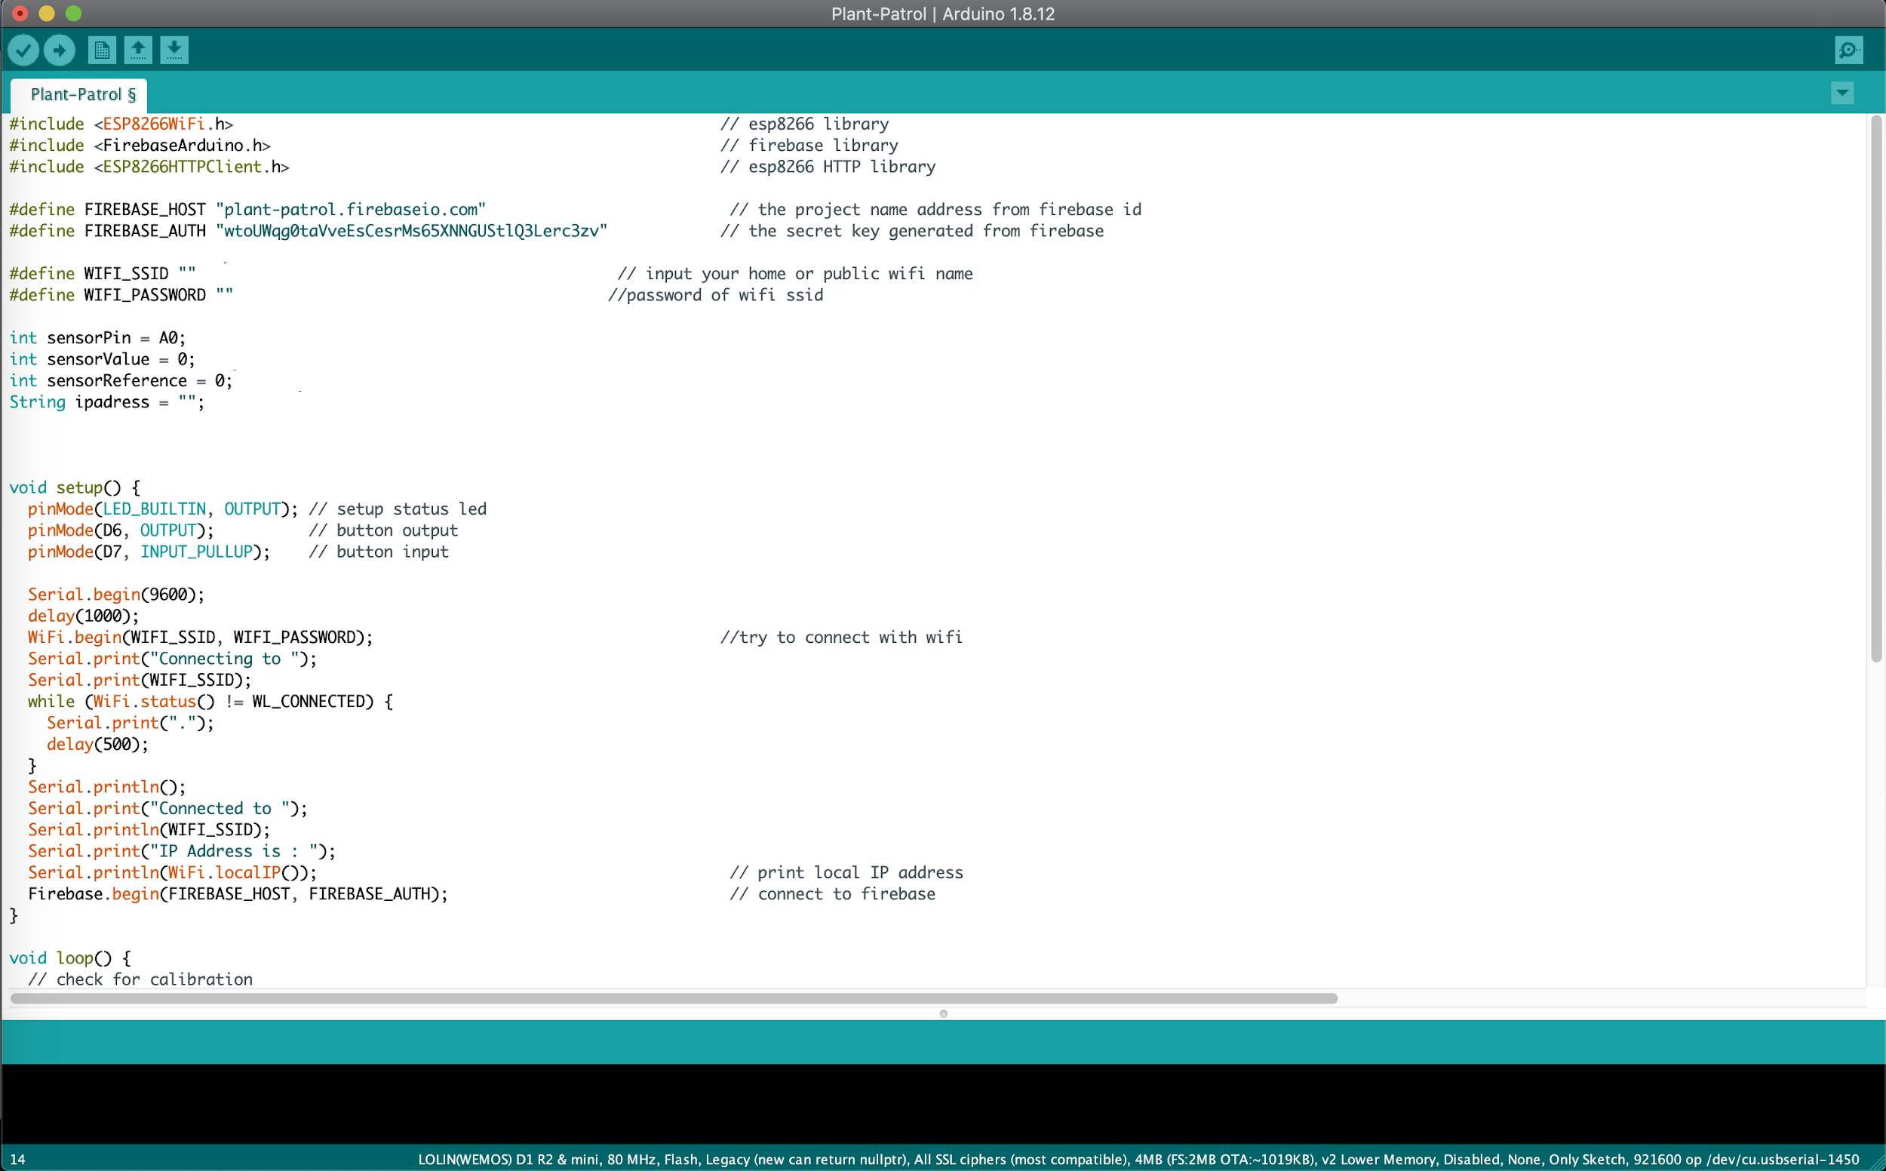

For the connection with Firebase, we are using a FirebaseArduino library. Download the correct version from github: <https://github.com/luukvlug1905/Plant-Patrol>**,** named FirebaseArduino.zip. Note: don’t unpack these files. Go to Sketch > Include Library > Add .ZIP Library. Now select the .zip you just downloaded and Arduino will add the library.

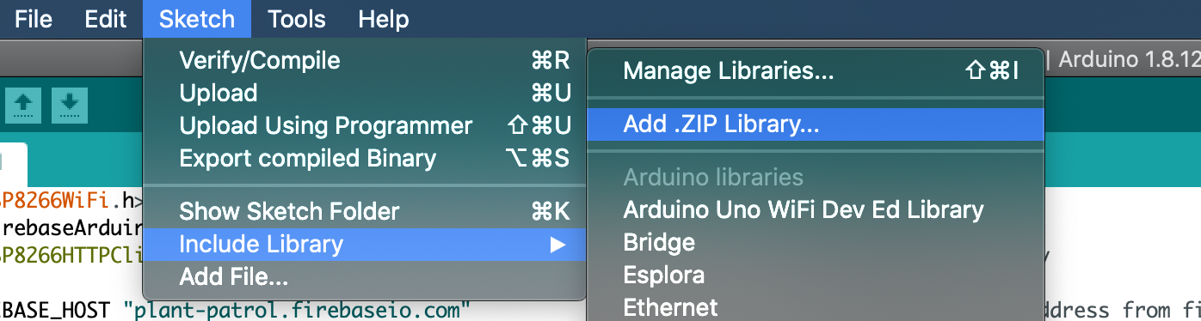

# Setting up the Wemos d1 mini

Now that the code has been installed, we will install a few more things to make this code able to run. For this project we are using a Wemos d1 Mini. This board is not available in Arduino yet, so let’s add it. Go to Arduino > Preferences:

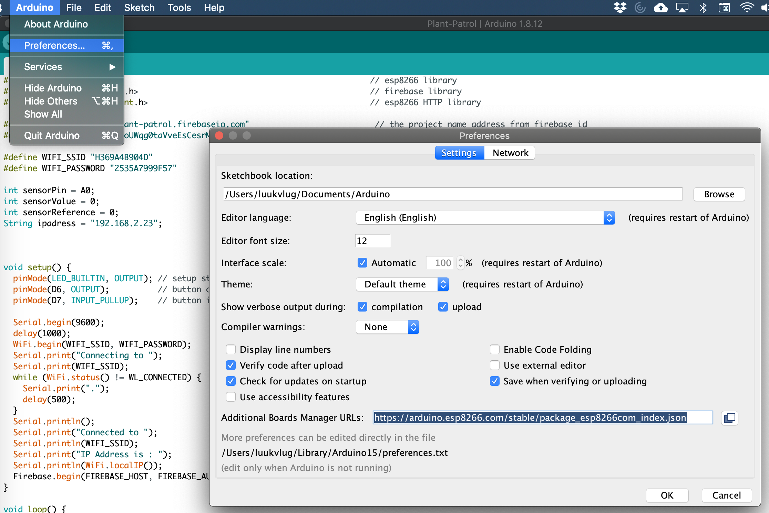

You will see this screen. Selected in the preferences screen, you will see a .json link. This link will download additional boards in Arduino, including the d1 Mini we are going to use. Just copy paste this link in there and press OK: <https://arduino.esp8266.com/stable/package_esp8266com_index.json>

Next we will do is select our newly added board in Arduino. Go to Tools > Board > LOLIN(WEMOS) D1 R2 & mini:

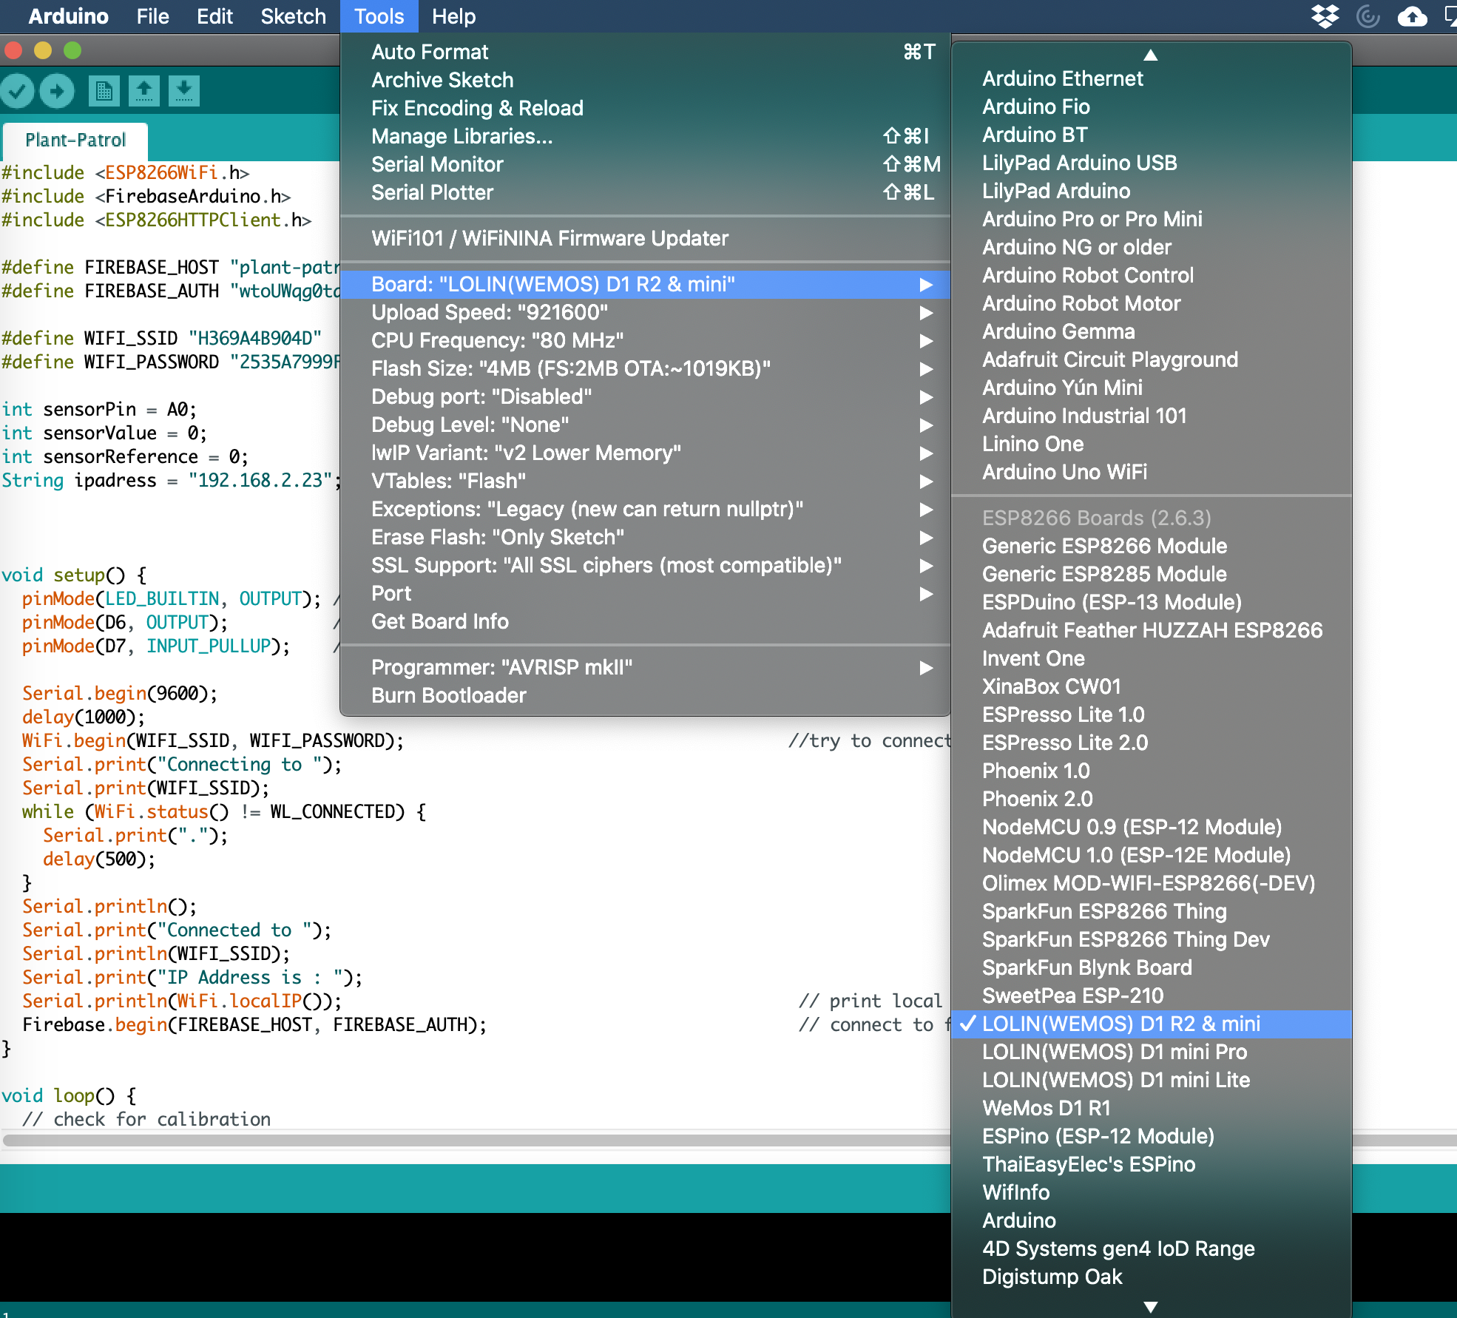

Now just plug in the sensor through USB or USB-C and proceed to the next step.

# Setting up the Arduino code

This is where you decide if you want to use a hotspot or wifi network. You can always change this later. The only difference in the code is the information you enter, and of course how stable and fast the connection is (wifi being faster than hotspot). Now, on how to connect the code to your chosen connection method. You will see 2 lines of code in Arduino, looking like this:



The only thing you will have to do is fill in the information asked within the quotation marks. So for SSID that will be your wifi OR hotspot name. For password this will be the password to your wifi or hotspot. If your wifi or hotspot does not have a password, leave the space empty.

Next thing we will need is the ip address of the device you’re going to start the application from. To find your ip address, do the following:

**Windows**: Press Windows key, type ‘cmd’, wait for the cmd to open and enter ‘ipconfig’. Your ip address, along with some other information will appear.

**Mac**: Press space + command, type ‘terminal’, wait for the terminal to open and enter ‘ifconfig’. Your ip address, along with some other information will appear.

Enter your ip address in the quotation marks here:

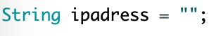

If the board is connected to your pc/laptop and you followed the steps above, you can now select the right USB port. This can be done in Tools > Port > select your USB port:

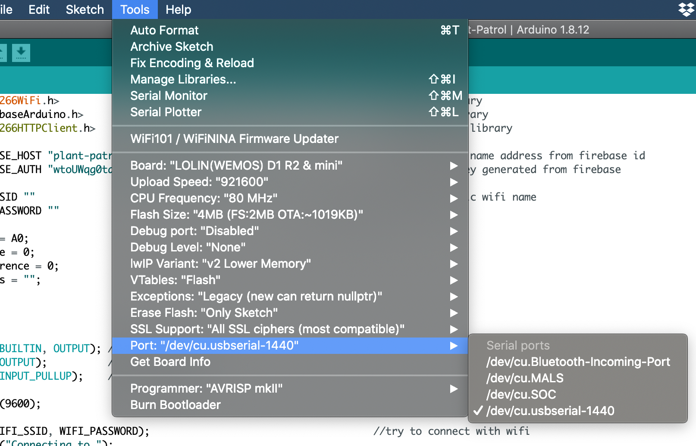

If you’re not sure what port you are using, you can always just try a few, it won’t do any harm, you will just see an error when uploading saying that the port is not connected or incorrect. To find out how to upload, read the instructions below.

Now you can upload your code. This can be done by pressing this button:

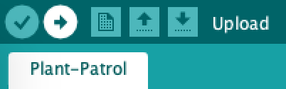

Now wait for it to upload, once you see it’s uploaded, open the serial monitor:

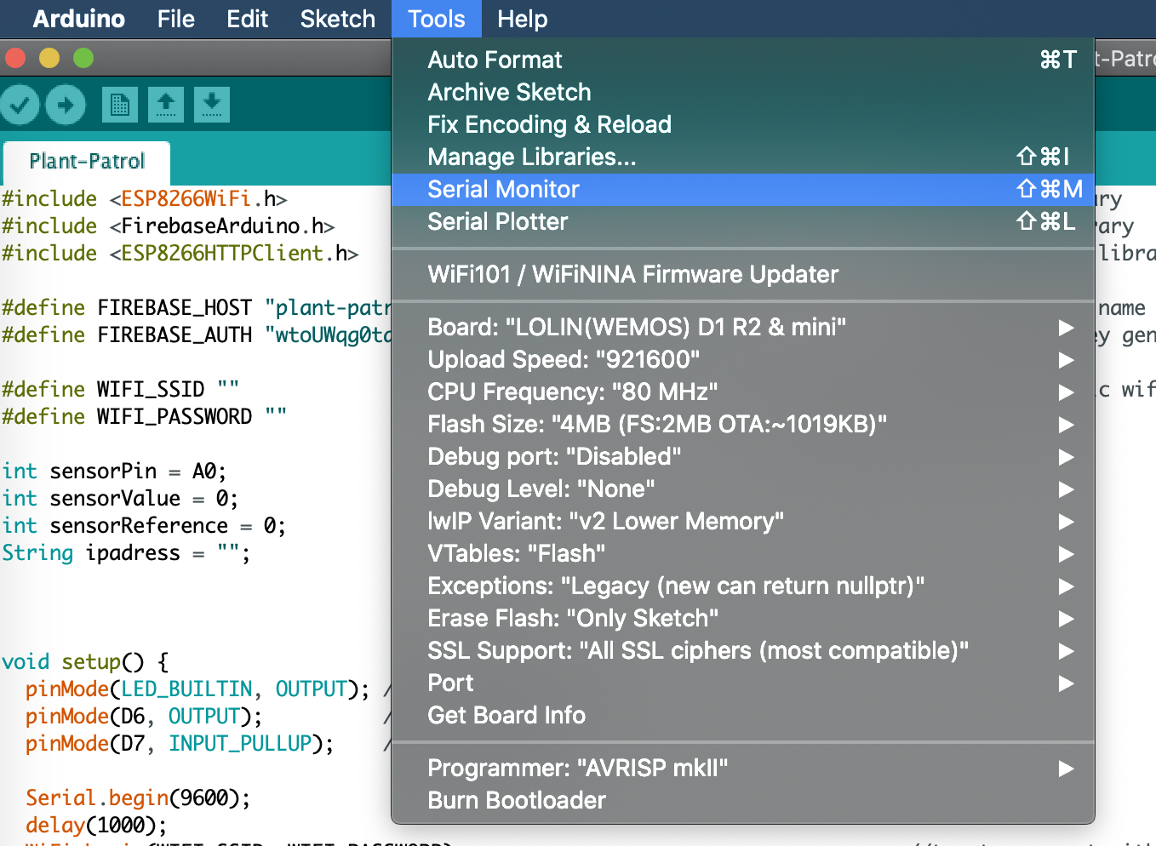

In the serial monitor you will see it trying to connect, if it’s just printing dots, it’s still trying to connect. Once connected, it will start printing moisture data, looking something like this:

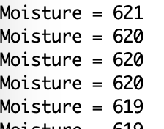

# XAMPP Setup

Now that you have the sensor running in Arduino, it is time to for the XAMPP Setup. Once again, make sure you have the latest version of XAMPP installed (at the time for making this guide 7.4.3): <https://www.apachefriends.org/download.html>. Also from github (<https://github.com/luukvlug1905/Plant-Patrol>) download the htdocs folder. Open XAMPP and press ‘Open application folder’.

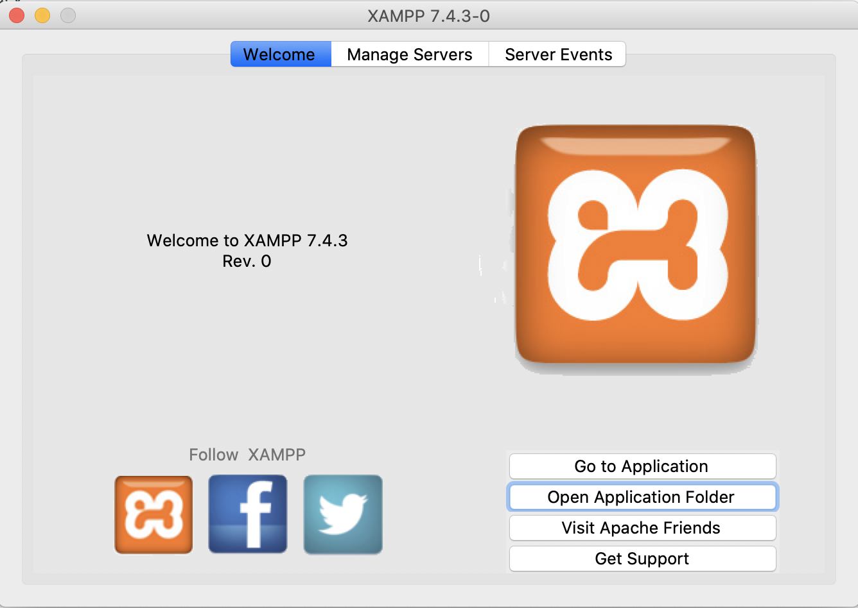

Here you will now see all the files in your finder/explorer. You will see a folder, htdocs. Replace this folder with the one you downloaded from github. If you are on MacOS, follow the next step, if not, skip ahead.

Rightclick the htdocs folder, click ‘Show info’.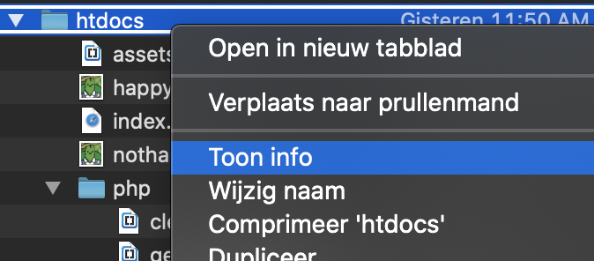

A new screen will pop up, on this screen, click on the disclosure triangle at the bottom,

looking like this:

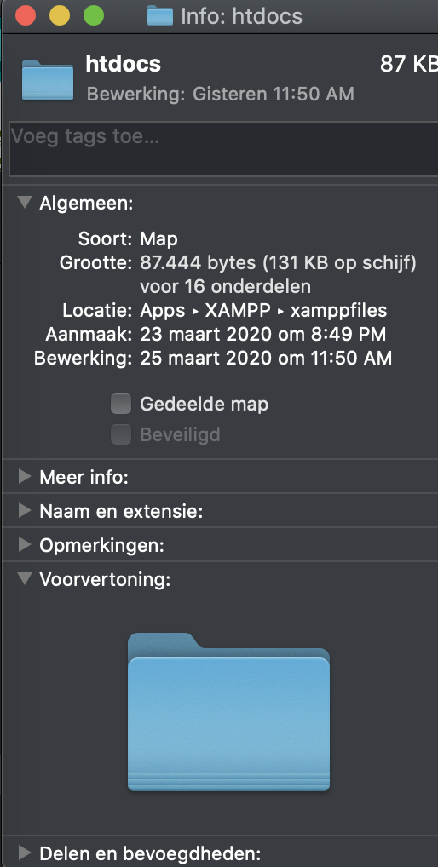

If your device is in English, this is called Sharing and Permissions. From here click the lock in the bottom right and enter your password. Now make sure all permissions are set to read and write. After changing them, press the lock again.

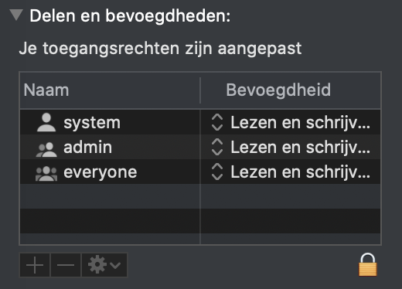

Repeat this step for the php folder within the htdocs folder.

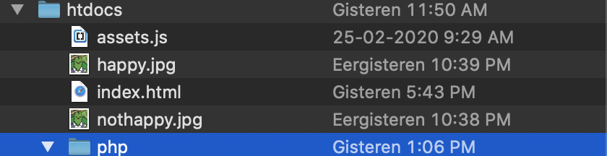

# Editing values for specific uses (optional)

There are values being used to decide whether the plant is happy or not. I set these values up in a way they’re applicable to most plants. If you want to use Plant Patrol for a specific type of plant only, you can always change these values. This option is made available because not every plant needs the same amount of water. A cactus for example needs way less water than your average palm. Here is shown how to change these values.

Open XAMPP again, and once again click on ‘Open application folder’. From here, right-click on php/plantstatus and open with. Now open it with the text editor you chose. In my case this will be Sublime. In the tab that opens, you will see this code:

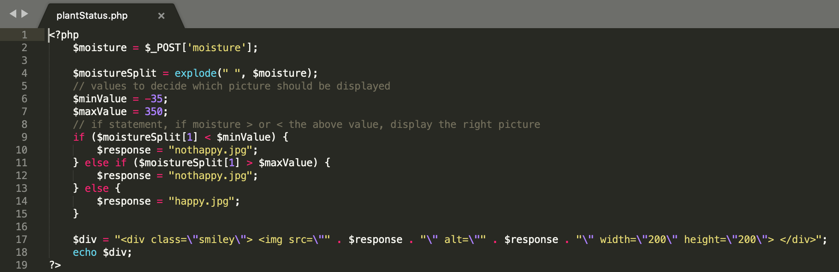

The 2 variables we are focussing on are minValue and maxValue. These values decide when the plant is happy or sad. In this case, if the moisture value is above 350, the plant will have too much water, therefore the plant will be sad. If the moisture value on the other hand is below -35, the potting soil will be too dry and the plant will be sad because he wants some water. Any value in between -35 and 350, the plant will be happy. The original values of the sensor are:

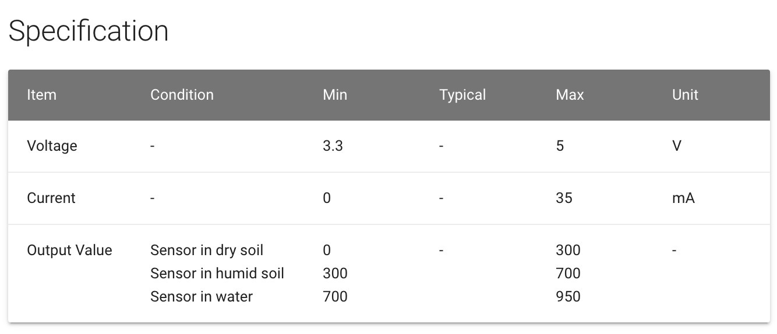

The reason why there is a negative value for minValue in the code is because of the calibration button. Follow the these steps to decide the perfect min- and maxValue for your plants:

1. Enter the sensor in the soil
2. Wait for the moisture value to stop rising or dropping and stay somewhat equal
3. Press the red button, making the value 0
4. Water the plant with the right amount of water
5. Set this value as maxValue
6. Take 10% of the maxValue and assign that as negative for the minValue (in my case, you can also take 30% for example)

Once the values are edited in both the variable assign rules (6&7) you can click on file > save. Now you can exit out of your chosen txt editor and the code will use the updated values.